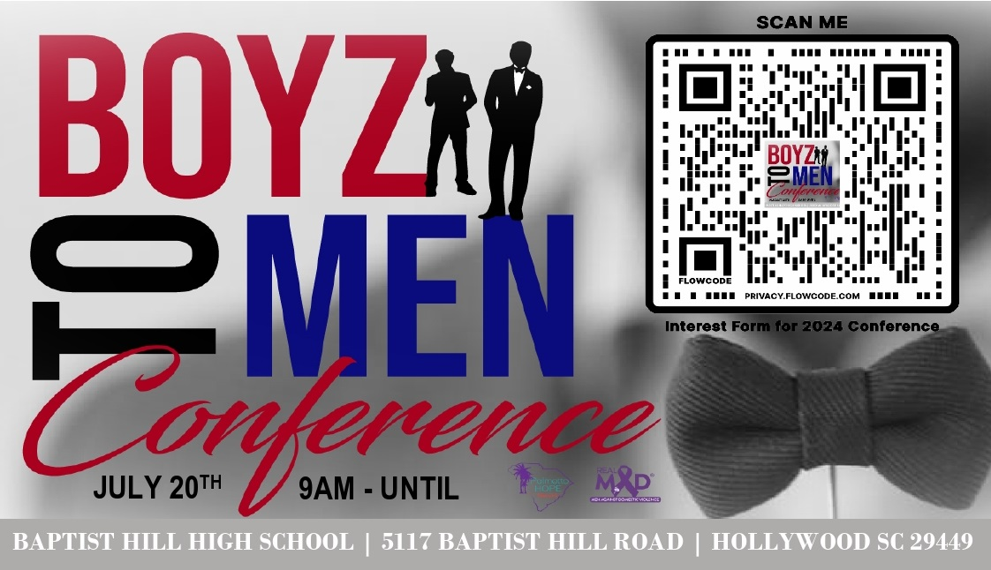

**For Immediate Release**

## Boyz to Men Conference Returns to Teach Healthy Masculinity to Youth

**Charleston, SC - July 18, 2023** – [Palmetto Hope Network and REALMAD (Real Men against Domestic Violence)](https://www.palmettohopenetwork.org/) proudly announce the return of the "Boyz to Men Conference," an event designed to empower young men and boys through mentorship, music, and modeling healthy masculinity. This year's conference takes place this Saturday, **July 20th, 2024 at Baptist Hill Middle High School in Hollywood, S.C.**

**Event Registration:**

This is a free event but space is limited. Please register your child or student via the organization’s [Eventbrite page.](https://www.eventbrite.com/e/boyz-to-men-conference-tickets-927805419987?aff=oddtdtcreator&fbclid=IwZXh0bgNhZW0CMTAAAR1wIh3kO9sAXl-wbLgSd4QwLXaTqsOUyjkuoq0ZCPfFj2w_agPrbaJwJh8_aem_qv0qvcso-Eyjx7YlTrZkAw)

Connect with and follow [PalmettoHopeNetwork](https://www.facebook.com/palmettohopenetwork) on Facebook for event updates.

**Baptist Hill Middle High School**

5117 Baptist Hill Rd.

Hollywood, SC 29449

July 20th, 9AM-4PM

**Event Highlights:**

The Boyz to Men Conference, now in its seventh year, is designed to provide young men and boys with alternatives and solutions to violence, promoting discussions on healthy relationships, and fostering respectful attitudes towards women and girls. Event founder, Marlvis (“Butch”) Kennedy says, "Expressing emotions, including anger, is an integral aspect of our discussions. We provide young men with tools to handle their emotions constructively, rather than suppressing them. This is crucial for preventing situations where unexpressed emotions manifest as destructive behavior."

The event has had a surge in participation in recent years. Last year, nearly 300 students, coaches, athletic directors, and community leaders from across the state participated in the full-day conference. Kennedy believes the increased turnout is largely due to word of mouth and the positive feedback the event has received from participants, parents, and the community. He also says a lot of parents are seeing “the escalating violence in our communities” and want to be sure their boys are “part of the solution, not the problem.”

**Purpose and Mission:**

The Boyz to Men Conference seeks to challenge traditional narratives around masculinity and provide a platform for young men and boys to discuss difficult topics.

“Young men grow up in a society that detaches them from their emotions,” Kennedy says. “This conference is part of a larger movement to redefine what we call ‘manhood.’ And that starts with teaching our boys how to feel and release their emotions in a healthy way….Ultimately, our goal is really to change the *culture*. We want to eliminate this culture of violence, degrading women, suppressing feelings in the name of 'masculinity.’”

The conference challenges the notion that young men should navigate life's challenges alone, learning the hard way. “Unlike the 'sink or swim' approach, our event creates an opposite environment that encourages open dialogues, support, and mentorship," Kennedy says.

Mentorship is the cornerstone of this conference. "Parents don't know how to have these tough conversations with their kids because often, they never went through what these kids are going through. The guys we bring in to share their stories have lived through the challenges that many of these kids are experiencing, so they’re able to connect with the kids in a way that makes them feel seen and understood."

**Conference Themes:**

The conference delves into a range of critical subjects, including bullying, domestic and gun violence prevention, healthy relationships, understanding emotions, financial education, and planning for college; topics that will benefit attendees long-term by exposing them to pathways for growth and personal development, and “give them the opportunity to change the trajectory of their life.”

Music is always a central theme of the event and a highlight for attendees. This year will feature a special music recording session and performance with Timeless Sounds J.R. Johnson and Gabriel Oree.

**Breakout Sessions:** These sessions give participants a chance to connect in small groups and provide a safe, confidential space for students to share openly with their peers. (Parents are encouraged to attend the special programming in the cafeteria and auditorium throughout the day, but are not allowed in breakout sessions.)

* **In the Recording Studio** with Timeless Sounds J.R. Johnson and Gabriel Oree (Ages 9+)
  + If you like to rap or sing this session is for you. We’re creating a mini recording studio where you can lay down your own track and leave with a copy of your song to share!
* **You are Favored** with Kelvin Waites (Ages 9+)
  + In today’s age, our young men and boys have so many distractions and outside influences that make them feel like they are no good and a failure. This session uplifts, encourages, and motivates our young boys and men to be the best men they can be. Host Kelvin Waites is a leader, coach, and former law enforcement officer.
* **Dress for Success** with Christopher Green (Ages 9+)
  + This session teaches our youth how to dress for success and why first impressions are important. Host Christopher Green is the founder and director of OpenMind Mentoring and he teaches young men about the importance of how we present ourselves.
* **Unspoken Effects of Gun Violence** with Wendell Manigault (Ages 9+)
  + Mr. Manigault will share his story of surviving an accidental gunshot wound and how family and faith have helped him overcome obstacles and cope with being permanently confined to a wheelchair.
* **Bullying Isn’t Cool** withDonald Kingcade (Ages 9+)
  + Mr. Kingcade is an author and has a ‘Stop Bullying’ campaign that he will share with our youth to help them understand the lasting impacts of bullying, for both victim and perpetrator.
* **Next Steps: Beyond High School** with Da’ron Hicks (Grades 9-12)
  + This session is specifically for High School students thinking about their next steps including college, how to fill out applications, budgeting, study habits, and resume building.
* **Man Cave** with Pastor Kevin Brown, Butch Kennedy, and other community leaders (Ages 16+)
  + This will be an open discussion addressing issues that men struggle with such as understanding and expressing emotions, healthy relationships, and violence prevention, to uplift these young men to become the best version of themselves.

**Event Safety:** Law enforcement will be present throughout the event to ensure a safe and secure environment for all participants.

**Registration:** To register your child or student for this event please go through the [Eventbrite page.](https://www.eventbrite.com/e/boyz-to-men-conference-tickets-927805419987?aff=oddtdtcreator&fbclid=IwZXh0bgNhZW0CMTAAAR1wIh3kO9sAXl-wbLgSd4QwLXaTqsOUyjkuoq0ZCPfFj2w_agPrbaJwJh8_aem_qv0qvcso-Eyjx7YlTrZkAw)

**Media Contact:**

Marlvis (Butch) Kennedy, Founder & Event Coordinator

(843) 324-7740  
[butchkennedy1060@gmail.com](mailto:butchkennedy1060@gmail.com)

**\*\*\*If you would like to include photos from last year’s conference in your story you can download them via this** [**link.**](https://jessica75008.editorx.io/boyz-to-men-2023/set/967d22c3-012a-4fcb-a094-3ebf4f2ef68a)

**Additional Information:**

Connect with and follow [PalmettoHopeNetwork](https://www.facebook.com/palmettohopenetwork) on Facebook for updates on this event and upcoming events including the 9th Annual Hope Walk against Violence onSeptember 14, 2024.

For information on other related programs including the Tri-County Gun Violence Coordinating Council (GVCC) please reference the following article: <https://www.palmettohopenetwork.org/post/gvcc-final-forum-summary>

###