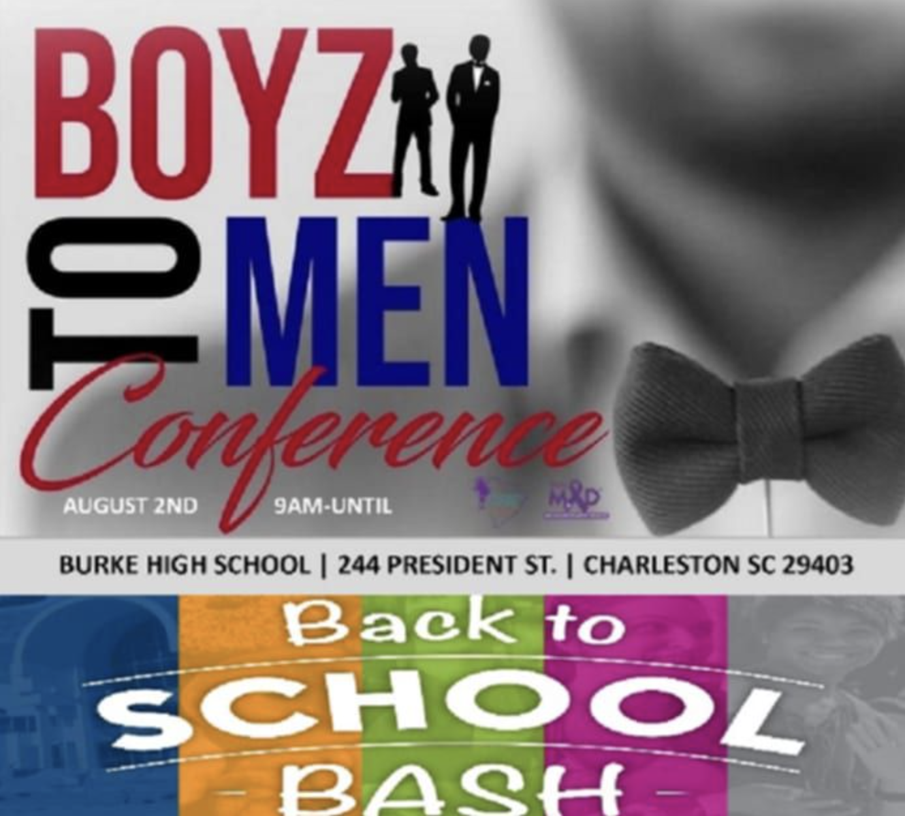

FOR IMMEDIATE RELEASE

# Boyz to Men Conference Returns to Empower Youth Amidst Rising Challenges

**Charleston, SC – July 19, 2025** – [Palmetto Hope Network and REALMAD (Real Men against Domestic Violence)](https://www.palmettohopenetwork.org/) proudly announce the return of the Boyz to Men Conference, a free, full-day event dedicated to equipping young men with the tools they need to grow into emotionally healthy, responsible leaders. Now in its eighth year, the conference will take place on **Saturday, August 2, 2025, at Burke High School, Charleston, S.C.**

**Registration:**This is a free event, but space is limited.   
**Register your child or student via Palmetto Hope Network’s** [**Eventbrite page**](https://www.eventbrite.com/e/2025-boyz-to-men-conference-and-back-to-school-bash-tickets-1431062328949?aff=erelexpmlt)**.**

**Follow** [@PalmettoHopeNetwork](https://www.facebook.com/palmettohopenetwork) **on Facebook** for updates.

**Event Details:  
Burke High School**244 President St.  
Charleston, SC 29403  
**August 2, 2025 | 9AM – 4PM**

## A Message of Urgency and Hope

As headlines grow more troubling — from the rise in hate speech online to ongoing attacks on DEI efforts and women’s rights — this year’s Boyz to Men Conference takes on heightened significance. The event aims to provide young men and boys with real-life tools to navigate the world with integrity, emotional intelligence, and purpose.

“We’re watching a dangerous cultural shift take hold — especially online — where toxic masculinity, violence, and misogyny are being normalized,” says conference founder **Marlvis “Butch” Kennedy**. “It’s more critical than ever that we speak directly to young men and show them a better way — how to stand up for themselves and others, how to express emotion in a healthy way, and how to protect the women and girls in their lives.”

## 

## Empowerment Through Mentorship, Music, and Meaningful Dialogue

With a dynamic mix of speakers, performances, and interactive breakout sessions, the **Boyz to Men Conference** provides a safe space for boys and young men to explore topics they may not feel comfortable discussing elsewhere, including mental health, masculinity, healthy relationships, and violence prevention.

The conference kicks off with the Burke High School Marching Band then opening remarks from **Charleston Police Chief Chito Walker**, followed by host introductions by **Butch Kennedy**, **Raphael James (Live 5 News)**, and **Terry Base (WJNI 106.3)**. Afternoon hosts include **Geno Jones (Star 99.7)** and **Dee Jay Cass (Z93 JAMZ)**.

**NEW THIS YEAR:**

* **Back-to-School Giveaway:** Every participant will receive a **backpack full of school supplies**. To donate, please contact Butch Kennedy directly.
* **Peer-Led Session with Zion Kendrick:** This new session is a direct response to feedback from past participants who said they wanted to hear from someone their own age who understands what they’re going through. Zion Kendrick, a basketball player and graduate of Goose Creek High School, is a relatable role model and a powerful peer voice. His session creates space for open, youth-led conversation where kids can **see themselves reflected in a successful young man**, ask honest questions, and hear real-life insights from someone who’s walking a similar path.
* **Evolved Man Cave Session:** A raw, honest conversation about **combating toxic masculinity** and redefining strength through accountability, vulnerability, and respect.
* **Parent Session: Dr. Zakevia Kendrick**, a licensed therapist and program manager for MUSC’s Violence Prevention Community Outreach Program, leads this session to teach parents how to talk with their children about difficult topics, including gun violence, trauma, and emotional well-being.

## Event Mission & Purpose

“Young men grow up in a society that detaches them from their emotions,” says Kennedy. “This conference challenges that. We’re creating a culture where emotional literacy, mentorship, and mutual respect are foundational. Our mission is to interrupt cycles of violence and create new pathways to healing, leadership, and self-worth.”

The event fosters peer connection and mentorship, offering participants the chance to hear from leaders who have walked in their shoes — and come out stronger for it.

## Conference Themes & Breakout Sessions

**Core themes** include:

* Mentorship
* Healthy Masculinity
* Mental and Emotional Health
* Domestic & Gun Violence Prevention
* Respect for Women and Girls
* Financial and Career Readiness
* Artistic Expression

## Breakout Session Highlights:

* **Recording Studio**: *Timeless Sounds* with JR Johnson & Gabriel Oree
* **The Value of Reading**: Christopher Davis
* **Dress for Success**: Christopher Green
* **Trades & Entrepreneurship**: Julian Williams
* **Unspoken Effects of Gun Violence**: Wendell Manigault
* **Wisdom is the Principal Thing**: Actor, Maxwell Highsmith
* **Maximizing Your Mentorship**: RezSaun Lewis,
* **Peer Group Session**: Zion Kendrick
* **Man Cave**: Geno Jones, Pastor Kevin Brown, Coach Eady, & Butch Kennedy
* **Parent Session**: *Let’s Talk* with Dr. Zakevia Kendricks, Lady T

## Musical Performances & Featured Appearances

* **Burke High School Band & Drumline**
* **North Charleston Steppers**
* **Additional Speakers include:** SC State Representatives, Wendell Gilliard and Jermaine Johnson; Charleston County Deputy Administrator of Public Safety, Eric Watson; Violence Interventionist, Ronald “Stunna” Smith; Boyz to Men Mentors, Isiah Hamilton, and Alvin Green Jr.

## Vendors & Community Partners

From mentorship organizations to law enforcement, the event’s vendor stations represent a wide range of services and resources for youth and families:

* [A Father’s Place](https://www.afathersplace.org/)
* [Lowcountry Youth Services](https://www.lowcountryyouth.org/)
* [Palmetto Hope Network](https://www.palmettohopenetwork.org/)
* [Boyz to Men Mentor Group](https://www.palmettohopenetwork.org/boyz-to-men-mentorgroup)
* [Positive Vibes / Ronjanae Smith Foundation](https://www.positivevibesronjanae.com/)
* [We Are Their Voices](https://www.wearetheirvoices.com/)
* [Art of Reading Depot](https://www.facebook.com/people/The-Art-of-Reading-Depot/100086067086863/)
* [Royal Residue](https://www.royalresidue.com/)
* [Timeless Sounds](https://www.facebook.com/TimelessSndsLLC/)
* [Charleston Leadership Council](https://www.charlestoncounty.org/mbp/leadership.htm)
* Boeing
* Charleston County Sheriff's Dept.

## Event Safety & Contact

Law enforcement will be present to ensure a safe environment for all participants.

**Event Registration:** Please register through [Eventbrite](https://www.eventbrite.com/e/2025-boyz-to-men-conference-and-back-to-school-bash-tickets-1431062328949?aff=erelexpmlt).

**Event Contact & Media Inquiries:** Marlvis (Butch) Kennedy  
 Founder & Event Coordinator  
 📞 (843) 324-7740  
 📧 butchkennedy1060@gmail.com

**Want to include photos from last year’s conference in your story?** **You can download them via this** [**link**](https://jessica75008.editorx.io/boyz-to-men-2023/set/967d22c3-012a-4fcb-a094-3ebf4f2ef68a).

## 

## Stay Connected:

Follow [@PalmettoHopeNetwork](https://www.facebook.com/palmettohopenetwork) on Facebook for updates on this and other upcoming events, including the **10th Annual Hope Walk Against Violence** on **October 4th, 2025**.

For more on related programming like the **Tri-County Gun Violence Coordinating Council (GVCC)**, read this [summary article](https://www.palmettohopenetwork.org/post/gvcc-final-forum-summary).

###