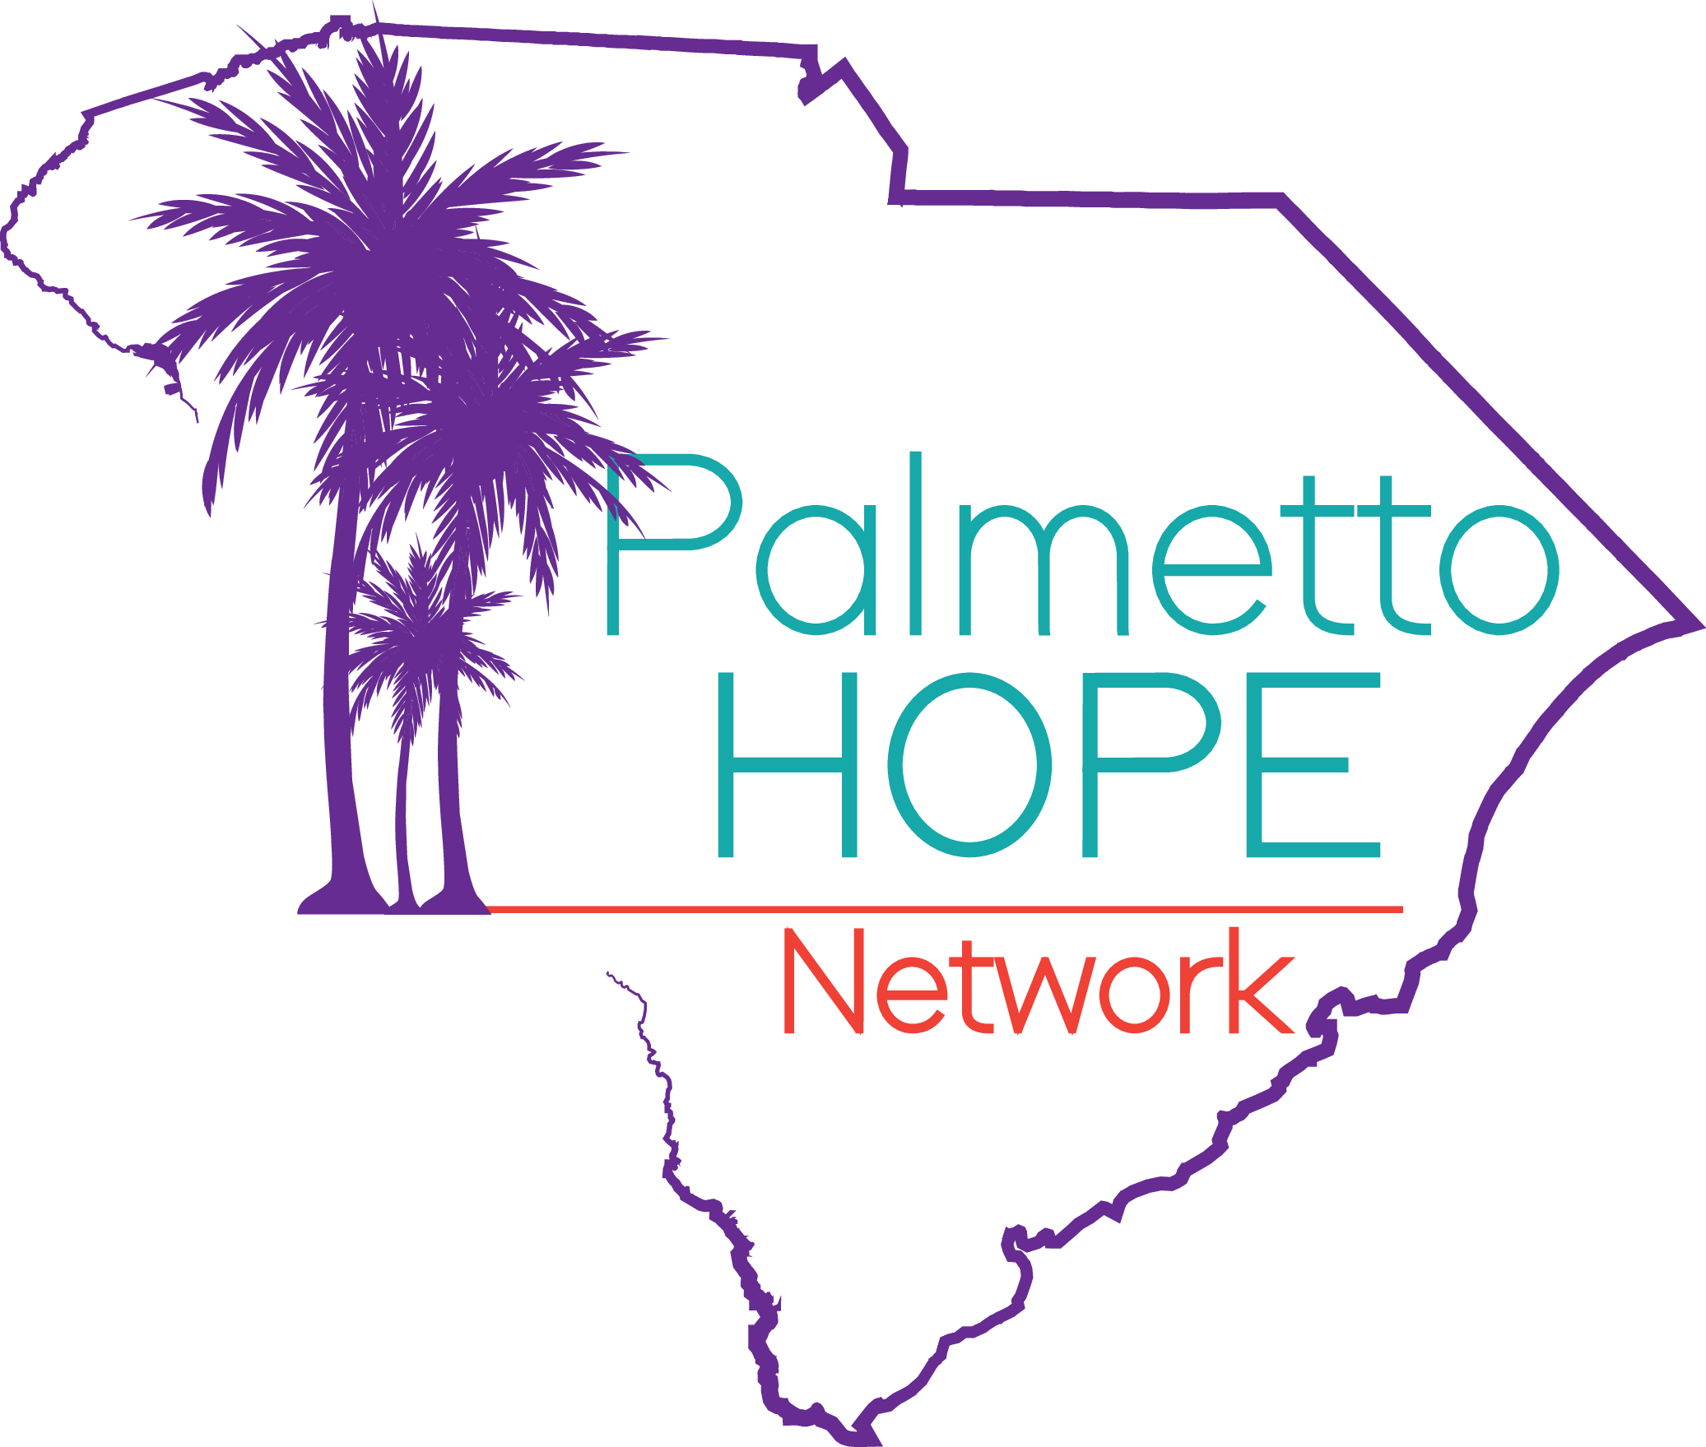

**FOR IMMEDIATE RELEASE**

## **State Funding Awarded to Palmetto Hope Network to Launch Navigational Center**

**January 8, 2025 | North Charleston, SC** — The [Palmetto Hope Network](https://www.palmettohopenetwork.org/) has received $200,000 of funding from the State of South Carolina to support its latest initiative to connect survivors of violent crime to critical resources. The funding will enable the establishment of the *Palmetto Hope Navigational Center*; a dedicated space where survivors of domestic violence and gun violence can access services to heal and rebuild their lives.

Located in North Charleston, the Palmetto Hope Navigational Center will serve as a central resource hub for Charleston, Berkeley, and Dorchester counties to connect clients to a comprehensive range of trauma-informed, wrap-around services, including crisis navigation, counseling, legal assistance, housing support, and employment resources. A lease has been signed for the facility, and an official opening date will be announced soon.

“This funding represents a significant step forward in our mission to empower survivors of violent crime,” said Butch Kennedy, Founder & CEO of the Palmetto Hope Network. “The Navigational Center will be a lifeline for individuals and families who need a safe, supportive environment to begin their journey toward recovery.”

The creation of the Navigational Center reflects Palmetto Hope Network’s vision for a community where survivors are supported through a strength-based approach, emphasizing their capacity for recovery and growth. The center aims to foster resilience, break the cycle of violence, and provide a beacon of hope for the Tri-County area.

### **Press Conference Announcement**

To celebrate this milestone, Palmetto Hope Network will host a press conference with Representative Wendell Gilliard, whose advocacy was instrumental in securing this critical funding. Details of the press conference are as follows:

* **Date:** Friday, January 10th, 2025
* **Time:** 11:00 AM
* **Location:** North Charleston City Hall, Buist Room 3rd Floor

“We are deeply grateful to Representative Gilliard and the State of South Carolina for recognizing the urgent need for a space like the Navigational Center,” said Kennedy. “Their commitment to this cause will make a lasting impact on our community.”

### **Contact and Upcoming Details**

Survivors seeking support can reach the Navigational Center at **843-904-2592**. While the center’s website is currently under construction, details on hours of operation and additional resources will be announced alongside the official opening date.

### **About Palmetto Hope Network**

Palmetto Hope Network has been providing services for domestic violence and gun violence victims for over 10 years. Palmetto Hope Network was founded to bridge gaps in support services for survivors of violent crime in the Tri-County area through advocacy, mentorship, training, and violence interruption and prevention services. The organization collaborates closely with social services, city officials, law enforcement, and community advocates to build networks of support and create pathways to healing and empowerment for survivors and their families. Palmetto Hope Network was instrumental in creating the [Tri-County Gun Violence Coordinating Council (GVCC)](https://www.palmettohopenetwork.org/tri-countygunviolencecoordinatingcouncil) and has established numerous outreach programs including the Boyz to Men mentor group and the annual [Boyz to Men Conference](https://www.palmettohopenetwork.org/post/boyz-to-men-conference-returns-to-teach-healthy-masculinity-to-youth).

###

**For media inquiries, please contact:**Butch Kennedy  
Founder & CEO, Palmetto Hope Network  
843-904-2592  
palmettohopenetwork@gmail.com   
[www.palmettohopenetwork.org](http://www.palmettohopenetwork.org)