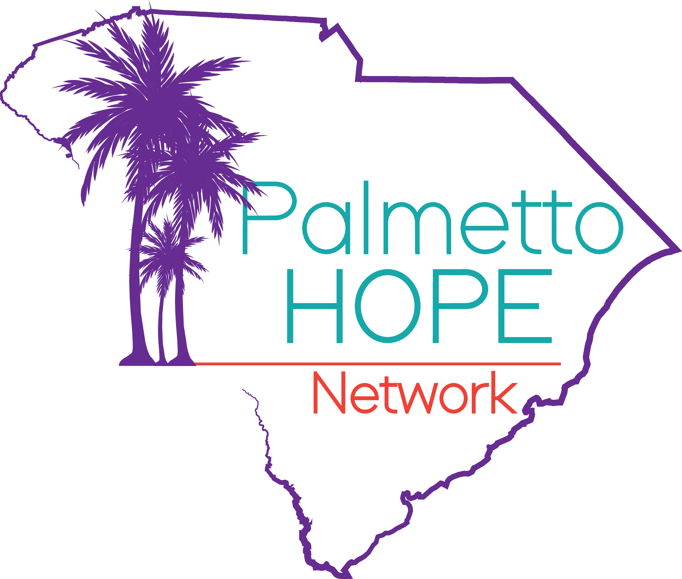

**FOR IMMEDIATE RELEASE** **Contact:** Butch Kennedy  
 **Phone:** 843-324-7740  
 **Email:** palmettohopenetwork@gmail.com  
 **Date:** April 17, 2025

### **“Hands Around the Statehouse” Rally Calls for Passage of the Senator Clementa C. Pinckney Hate Crimes Act**

**Columbia, SC – On Wednesday, April 23, 2025, at 11:00 AM**, citizens from across South Carolina will gather on the North Grounds of the Statehouse (1100 Gervais St., Columbia, SC) for a “Hands Around the Statehouse” rally. The event sends a powerful and unified message: “Hate no longer lives in South Carolina.”

Organized by Palmetto Hope Network, the Tri-County Gun Violence Coordinating Council, National Action Network, Project Unity USA, and a coalition of legislators, advocates, community leaders, and concerned citizens, **the rally demands that the South Carolina General Assembly take long-overdue action to address hate crimes in the state.**   
  
Ten years after the racially motivated mass shooting at Mother Emanuel AME Church in Charleston, the Senate has yet to hold a vote on hate crime legislation. South Carolina remains one of only two states (including Wyoming) without a hate crime law.

Organizers are calling on the **South Carolina Senate Judiciary Committee, led by Chairman Luke Rankin**, to take immediate action by scheduling a hearing and vote on the “**Senator Clementa C. Pinckney Hate Crimes Act” (H.3039 / S.247)**, sponsored by Rep. Wendell Gilliard and Sen. Darrel Jackson. Versions of this bill have passed the House three times, only to stall in the Senate. With the legislative session ending on May 8, supporters are urging lawmakers to act swiftly to pass the bill so it can reach Governor McMaster’s desk to be signed into law.

Passing this bill would give local law enforcement stronger tools to track and prosecute hate crimes, filling the gap in South Carolina’s legal system. It would also enhance penalties for crimes motivated by bias, helping to deter future violence and protect vulnerable communities.

Supporters of the bill state, "We realize that we cannot rely solely on federal law enforcement to prosecute and track hate crimes occurring in our state. It is long past time that South Carolina enshrines in law what we already believe: that committing a criminal act motivated by hate for someone because of their real or perceived race, religion, nationality, gender, gender identity, sexual orientation, or disability is unacceptable."  
 **About the Senator Clementa C. Pinckney Hate Crimes Act (H. 3039 | S. 247)**

**The new law would:**

* **Increase penalties** for violent crimes motivated by hate, adding **up to five years in prison** and a **$10,000 fine** to the offender's sentence.
* **Protect victims** targeted for their **race, color, religion, sex, gender, national origin, sexual orientation, or physical or mental disability.**
* **Require proof of bias**: A **jury of peers** must determine beyond a reasonable doubt that the crime was motivated by hate, with **legal safeguards** allowing the defense to challenge the claim.
* **Track hate crime offenders:** Helps law enforcement **identify patterns**, such as **repeat offenders, targeted groups, or high-risk areas**, making communities safer and **encouraging more victims to come forward**.

**A Call for Accountability After a Decade of Inaction**  
As we approach the anniversary of the tragedy at Mother Emanuel Church, this year’s event marks a particularly poignant milestone in the families' pursuit of justice and reform. In the 10 years since the deadliest mass shooting in the state’s history, the South Carolina General Assembly has failed to pass any effective legislation to protect victims of hate crimes or send a clear message to those who would commit acts of racial violence.

Family members of the Emanuel 9 will be present at the Statehouse, and Rep. Wendell Gilliard will speak to call for accountability, compassion, and long-overdue action from state lawmakers. Gilliard suggests that this failure to act raises serious questions about the priorities of the South Carolina legislature; "For the sake of the victims and their families—and the safety and dignity of all South Carolinians—this bill must pass. It is long past time for us to send a clear statement that South Carolina stands firmly against hate and will no longer allow such violence to define us."

**Join Us**

South Carolina deserves stronger protections for all its people. **“Hands Around the Statehouse” is a powerful call to action for everyone who believes in equality, justice, and accountability**.

Together, we will link hands in solidarity against hate and a shared commitment to healing through community. We hope you’ll join us.

📍 **Event Details:** 🗓️ **Date:** Wednesday, April 23, 2025  
 ⏰ **Time:** 11:00 AM  
 📍 **Location:** SC Statehouse – North Grounds  
 **1100 Gervais St., Columbia, SC 29201**

\*\*\***For anyone who cannot make it to the Statehouse in person, you can still help us put pressure on the SC Legislature by contacting your Representatives and asking them to support H.3039.**

For more information or to get involved, contact Butch Kennedy at [palmettohopenetwork@gmail.com](mailto:palmettohopenetwork@gmail.com) or call 843-324-7740.

### **About Palmetto Hope Network**

Palmetto Hope Network has been providing services for domestic violence and gun violence victims for over 10 years through advocacy, mentorship, training, and violence interruption and prevention initiatives. The organization recently opened the **Palmetto Hope Crisis Navigation Center**, which connects victims across Charleston, Dorchester, and Berkeley counties to essential wrap-around services, including mental health counseling, legal support, housing, and financial assistance. Palmetto Hope collaborates closely with social services, city officials, law enforcement, and community advocates to build networks of support and create pathways to healing and empowerment for survivors and their families. Palmetto Hope Network also leads the **Tri-County Gun Violence Coordinating Council (GVCC)** and hosts the annual **Boyz to Men Conference**, focused on mentorship and empowerment.

###

**For media inquiries, please contact:**Butch Kennedy  
Founder & CEO, Palmetto Hope Network  
843-324-7740  
butchkennedy1060@gmail.com   
[www.palmettohopenetwork.org](http://www.palmettohopenetwork.org)