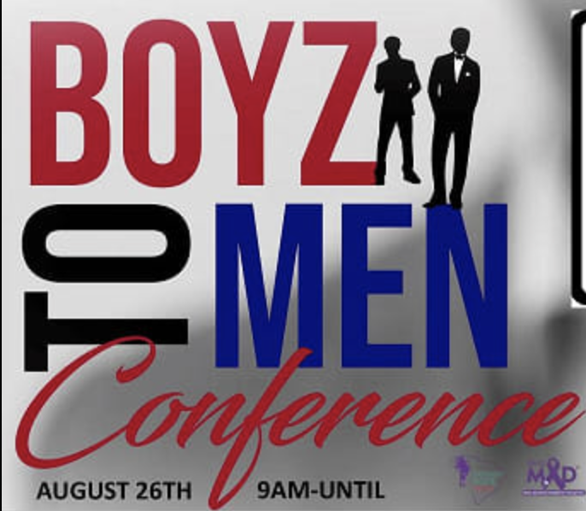

**For Immediate Release**

## Boyz to Men Conference Empowers Youth and Redefines Manhood

**Charleston, SC - August 17, 2023** – [Palmetto Hope Network and REALMAD (Real Men against Domestic Violence)](https://www.palmettohopenetwork.org/) proudly announce the return of the "Boyz to Men Conference," an event that transforms lives and reshapes perspectives, designed to empower young men and boys while fostering respectful attitudes towards women and girls. This year's conference will take place on August 26, 2023, at West Ashley High School in Charleston, SC.

**Event Highlights:**

The Boyz to Men Conference, now in its sixth year, is witnessing an inspiring surge in participation among young men and concerned parents. Event founder, Marlvis (“Butch”) Kennedy believes the increased turnout of young men and concerned parents in recent years is “in response to the escalating violence in our community.”

The full-day conference is designed to provide young men and boys with alternatives and solutions to violence, promoting discussions on healthy relationships, and encouraging respect for all individuals. "Expressing emotions, including anger, is an integral aspect of our discussions. We provide young men with tools to handle their emotions constructively, rather than suppressing them. This is crucial for preventing situations where unexpressed emotions manifest as destructive behavior." Kennedy says.

Over 320 students, coaches, athletic directors, and community leaders from across the state will participate and engage with a diverse set of speakers and facilitator-led breakout sessions, as well as musical performances by local artists, [CHOYCE](https://onechoyce.com/), Walter [REAL](https://www.facebook.com/walterreal.hills/) Hills, [Brandon Noir](https://unitedmasters.com/a/brandon-noir), and the West Ashley band & drumline. The music, Kennedy says, is always a highlight for the kids.

**Keynote Speakers and Presenters:**

The conference proudly welcomes Chief Eric Watson (Charleston County Deputy County Administrator of Public Safety) and SC Representative Wendell Gilliard as keynote speakers. Additionally, the event will feature a welcome address from Mayor John Tecklenburg, and presentations from actors Cyrus Birch and Maxwell Highsmith. Musicians, mentors and clergy from various backgrounds will also be present to share their personal journeys to manhood, offering valuable insights, life lessons, and musical performances. The event will be hosted by local TV and radio personalities Raphael James Live 5 News, Terry Base WJNI 106.3FM, Geno Jones STAR 99.7, and Dee Jay Cass Z93 JAMZS.

The organizers’ commitment to improving community betterment is matched by the unwavering dedication of the volunteers, speakers, and workshop leaders who generously contribute their time and stories.

**Additional Speakers include:**

* Alvin (AJ) Green Jr.: Mentor, Boyz to Men
* Isiah Hamilton IV: Mentor, Boyz to Men
* Wendell Manigault: Author & Youth Speaker
* Daniel Bryant: Art teacher at Oakbrook Elementary, Dorchester County
* Jimmy Strong: Engineer, Boeing

*(*See the list of breakout session leaders below)*

**Purpose and Mission:**

The Boyz to Men Conference seeks to challenge traditional narratives around masculinity and provide a platform for young men and boys to discuss topics that were previously shrouded in silence.

“Young men grow up in a society that detaches them from their emotions,” Kennedy says. “This conference is part of a larger movement to redefine what we call ‘manhood.’ And that starts with teaching our boys how to feel and release their emotions in a healthy way….Ultimately, our goal is really to change the *culture*. We want to eliminate this culture of violence, degrading women, suppressing feelings in the name of 'masculinity.’”

The conference challenges the notion that young men should navigate life's challenges alone, learning the hard way. “Unlike the 'sink or swim' approach, our event creates an opposite environment that encourages open dialogues, support, and mentorship," Kennedy says.

Mentorship is really the cornerstone of this conference. "Parents don't know how to have these tough conversations with their kids because often, they never went through what these kids are going through. The guys we bring in to share their stories have lived through the challenges that many of these kids are experiencing, so they’re able to connect with the kids in a way that’s real, that makes them feel seen and understood."

AJ Green and Isaiah Hamilton, for example, were mentees of Butch Kennedy as teenagers. Now, they are now helping to run the conference and will both be speaking at this year’s event. Their journey exemplifies the both conference's mission and Kennedy’s steadfast commitment to provide young men with a supportive community and a pathway to positive change.

**Conference Themes:**

In addition to talking about domestic and gun violence prevention, the conference delves into a range of critical subjects, including healthy relationships, understanding emotions, financial education, and entrepreneurship; topics that will benefit attendees long term by exposing them to pathways for growth and personal development, and “give them the opportunity to change the trajectory of their life.”

This year, they are also adding discussions around food insecurity and the importance of nutrition, subjects rarely discussed in many low-middle income communities. “We know now that poor nutrition is directly linked to poor behavior.” Kennedy says. The prevalence of cheap, unhealthy fast food options in low-income areas underscores the importance of raising awareness about healthy choices.

**Breakout Sessions:**

* Facing the Man in the Mirror: Christopher Green (Founder & Executive Director, [Open Mind Mentoring](https://www.openmind-mentoring.org/))
* Trades and Entrepreneurship: Julian Williams (Master Blacksmith, [JDW Blacksmith](https://m.facebook.com/jdw.blacksmith.7/))
* Mentors Matter: ReZsaun Lewis (Founder & Executive Director, [Lowcountry Youth Services](https://www.lowcountryyouth.org/))
* Mental Health: Dr. Marcus Dupree (Mentor & Counselor)
* Resilience and Decision-Making: Kenneth Joyner (Co-founder, [Boys With a Purpose](https://www.boyswithapurposesc.org/))
* Music Industry Insights: Charleston natives, [CHOYCE](https://onechoyce.com/) (Christian artist, musician); Walter [R.E.A.L](https://www.facebook.com/walterreal.hills/). Hills (Music Artist/Founder at [Prize Musik](https://www.facebook.com/prizemusik)); [Brandon Noir](https://unitedmasters.com/a/brandon-noir) (Singer-Songwriter, Musician)
* Financial Literacy: Kevin Simmons (Vice President, First Capital Bank; motivational speaker)
* Ending Gun Violence: Ron Smith (Founder, [Ronjanae Smith Positive Vibes, Inc](https://www.positivevibesronjanae.com/).) and Pastor Thomas Dixon (Associate Pastor at Life Community Church in Mt Pleasant, SC)

**Parent Sessions:** Parents are encouraged to attend special programming in the cafeteria and auditorium throughout the day, but are not allowed in breakout sessions in order to provide a safe, confidential space for students to share openly with their peers.

* Manhood and Interpersonal Relationships: A.J. Davis (School Advocate, Burke High School)
* How Drill Rap Glorifies Violence: (Panelist session)

**Event Safety:** Law enforcement will be present throughout the event to ensure a safe and secure environment for all participants.

**Registration & Additional Information:**

This is a free event but space is limited. [Online registration is open until August 25th via Eventbrite](https://www.eventbrite.com/e/2023-boyz-to-men-conference-tickets-577140080517?aff=oddtdtcreator&fbclid=IwAR2fEQkhA7Ep00_DjIwTFQpsXN2jIYzD69quLydHEIFc7iTQtgKko5gIc74) [linked]

Connect with and follow [PalmettoHopeNetwork](https://www.facebook.com/palmettohopenetwork) on Facebook for updates on this event and upcoming events including the 8th Annual Hope Walk against Violence on September 9, 2023.

For information on other related programs including the Tri-County Gun Violence Coordinating Council (GVCC) please reference the following article: <https://www.palmettohopenetwork.org/post/gvcc-final-forum-summary>

###

**Media Contact:**

Marlvis (Butch) Kennedy, Founder & Event Coordinator

(843) 324-7740  
[butchkennedy1060@gmail.com](mailto:butchkennedy1060@gmail.com)

**\*\*\*If you would like to include photos from a past conference in your story you can download them here:** <https://www.2021boyz-to-men-con.palmettohopenetwork.org/sets>