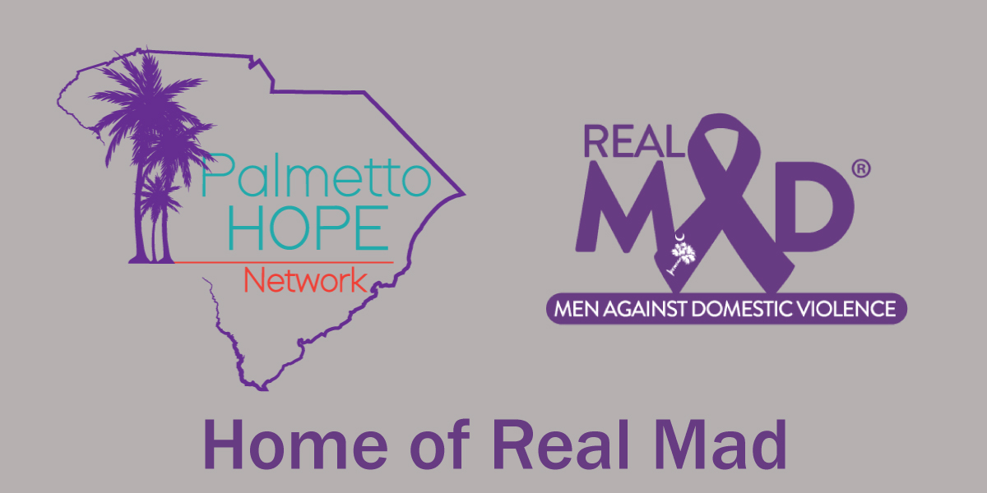

**For Immediate Release**

### **Community Forum on Domestic Violence Aims to Address Critical Issues in South Carolina**

**Charleston, SC, April 2, 2024** - In response to the pressing need to address domestic violence in South Carolina, Palmetto Hope Network is hosting a Community Forum on April 10th starting at 9 AM at the Teddie E. Pryor, Sr. Social Services building at the Department of Social Services in North Charleston. The event aims to shed light on the current state of domestic violence in the state, expose systemic pitfalls, and explore actionable solutions to support survivors.

South Carolina ranks sixth-worst in the nation for women killed by men, according to the annual "When Men Murder Women" report published in September 2021. The latest data from the Violence Policy Center underscores the severity of the situation, with approximately two women killed for every 100,000 people in the state—a death rate more than twice the national average. Tragically, many of these incidents involve firearms, exacerbating the danger faced by victims.

Event coordinator, Marlvis 'Butch' Kennedy, emphasizes the critical importance of raising awareness about the increasing rate of domestic violence in the state in recent years: "In light of COVID-19, domestic violence has increased in our communities. Our organization and many others continue to sound the alarm about what needs to be done to address this issue, yet the state struggles to implement meaningful measures toward eradicating domestic violence to make our state safer. So the question I have for the state of South Carolina, is do you really care about these victims? Because your policies say you don’t.”   
  
The agenda for the event will focus on key points such as creating a safety net for survivors and understanding that leaving an abusive situation is only the first step. As highlighted by Kennedy, "It's easy to leave, but how do you survive after? Let's create a safety net that actually catches them. What should that safety net look like?" It's imperative to recognize that the risk of harm continues even after survivors leave, with statistics showing that 50% of injuries and 75% of domestic homicides occur after the relationship ends. And since My Sister’s House closed the only domestic violence shelter in the Tri-County area in 2022, the various organizations that currently service victims are unable to meet current housing needs. The Lowcountry is now the only area in the state without a shelter.   
  
The event’s objectives include providing resources, exposing pitfalls within the system, and identifying at least three top-priority actionable items for attendees to take away. Through panel discussions and interactive sessions, attendees will gain valuable insights into the complexities of domestic violence and the urgent need for comprehensive support systems.

The event will be Co-Hosted by Butch Kenndy, Lisa Rahiem-Kennedy (Outreach Coordinator, Palmetto Hope Network, REALMAD (Real Men against DV), and Hailey Lapa (Origins SC, Victims Advocate). Confirmed speakers and panelists include Elmire Raven (former director of My Sister's House), Tonya Dennis ( Investigations Team Leader, Dept. of Social Services), and Cheryl Wright (SC Legal Services).Attendees will also hear testimonies directly from victims of domestic violence.

The event will also facilitate a solutions conversation, encouraging attendees to actively participate in identifying actionable solutions. Audience members will be invited to volunteer for a task force aimed at cultivating solutions to address domestic violence in South Carolina. Full names and contact information will be collected to ensure follow-up and collaboration beyond the forum.

Together, we can work towards creating a safer and more supportive environment for survivors of domestic violence in South Carolina. Join us for this crucial discussion and be a part of the solution. For media inquiries and further information, please contact Butch Kennedy.

**Media Contact:**

Butch Kennedy

[butchkennedy1060@gmail.com](mailto:butchkennedy1060@gmail.com)

843-324-7740

[www.palmettohopenetwork.org](http://www.palmettohopenetwork.org)

**Event Details:**

**Date**: Wednesday, April 10, 2024

**Time**: 9:00 AM - 3:00 PM (includes one hour lunch break)

**Location**: 3685 Rivers Avenue, North Charleston, SC 29415

**Registration:** <https://docs.google.com/forms/d/1UbUMacpPbJw_ICHZXsi89oQrU2pEoDXaL4HOUwdj7eU/viewform?edit_requested=true>